E-COMMERCE IN INDIA
Amazon & Flipkart

Kajal Raj

Table of Contents

- Introduction 1
  - Background 1
  - Motivation 3
  - Purpose 4
  - Thesis outline 4
- Methodology 5
  - Research methods 5
  - Research approach. 6
  - Limitations 6
- Literature Overview 7
  - E-commerce 7
  - E-commerce business categories 9
  - Impact of e-commerce 11
    - Social 11
    - Supply chain management 12
  - Factors affecting e-commerce 14
  - Government policies 15
  - Logistics 18
    - Overview 18
    - Logistics evolution 21
    - Handling and order processing 25
    - Transportation 28
    - Outsourcing. 28
- Case one – Amazon India 30
  - Introduction 30
  - Competition 31
  - Services 33
  - Business process and model 34
  - Amazon logistics structure and operation 35
    - Ordering 35
    - Inventory management 36
    - Order execution 37
    - Shipping 38
    - Tracking 38
    - Payments 38
    - Order cancellation and substitution 39
    - Return policy 39
- Case Two - Flipkart India 41
  - Introduction 41
  - Business model 42
  - Flipkart logistics structure and operations 42
- Analyses 52
  - Cross analyses between Amazon and Flipkart 52
  - SWOT Analysis 57
  - PORTER Analysis 63

- Types of Testing……………………………………………………………..…65

- UML Diagrams……………………………………………………………….. 68
9.Conclusion 73
List of figures & tables 75

ABSTRACT

In the last two decade, world has witness an incredible growth of Internet and has changed the way organization conduct business. It has provided a new option for conducting business named e-commerce. It is basically selling and buying through internet using computers.

The purpose of this study is to first understand the e-commerce and its impacts. Further understanding of logistics and its role in e-commerce. A case study of Amazon and Flipkart India is then done to explore their business strategies, operations, logistics functioning etc. Cross analysis of Amazon and Flipkart in terms of market share, revenue etc. is done next. A SWOT and PORTER analysis is then performed based on it. It helped in coming to the conclusion about future strategies needed by both companies to remain competitive in market.

To reach this purpose, a qualitative research approach was used where case study on Amazon India is conducted. The data is collected through books, Internet and interviews.

The finding of our analysis shows that despite increased revenue and sales both Amazon and Flipkart still faces many challenges such as IT security - vulnerability to hacking, low margins due heavy discounting, loopholes in distribution system etc. Especially during festival season when sales are usually at peak many complain such as late delivery, website non-functioning occurs. This seriously impact the company image and raises doubt on its operational capabilities.

In the conclusions, the steps taken by both the companies such as new payment gateways etc is discussed which are taken to counter some of the major threats that are affecting both the companies such as heavy losses due to discount, logistics inefficiency, expansion to smaller cities etc.

Keywords: E-commerce, Logistics, Amazon, Flipkart, Internet.

Introduction

This section gives an overview about e-commerce background and its development over the years

Background

Electronic commerce or commonly known as E-commerce in simple term is buying, selling and exchange of services over the internet. In the last decade with increased penetration of internet and smartphones around the globe, e-commerce technology has developed quickly which made people life easier. E-commerce mainly B2C (business to consumer) makes the most part of e-commerce in today’s world where seller can sell good to online customer via internet.

During 1960, primitive computers networks were used to conduct electronic transactions in business. Using Electronic Data interchange (EDI), a company’s computer system could share business documents such as invoices, delivery confirmations etc. with other company’s computer. The main problem in the beginning was the different document formatting standard used by each company. In 1979, the American National Standards Institute (ANSI) introduced ASC X12, a universal standard for sharing business documents over electronic network. In 1982, transmission from ARPAnet switched over to Transmission Control Protocol and Internet Protocol (TCP/IP), the technology that powers the modern Internet today.

In 1980, individual computers were mostly used at research universities. It was used for sending e-mails, sharing research documents etc. over networks like BITNET. For home personal users, CompuServe was popular for providing tools like e-mails and chat rooms. It added a service called Electronic Mail which users can purchase from service provider called 110 online. It was not very successful initially but it laid foundation for the e-commerce we know today. In 1990, a researcher named Tim Berners-Lee at the European Organization for Nuclear Research proposed a hypertext-based web of information in which a user could navigate using a simple interface called a browser. He called it the "Worldwide Web".

In 1991, ban on commercial businesses operating over the internet was lifted by the National Science. It opened the way for Web-based e-commerce.
In 1993, the National Centre for Supercomputing Applications (NCSA) introduced the first web browser named Mosaic. Similarly, Netscape 1.0 was released in 1994 which included an important security protocol called Secure Socket Layer (SSL). It encrypted messages on both the sending and receiving side of an online transaction. It ensured encryption of personal information like names, addresses and credit card numbers when they passed over the Internet

First third party services for processing online credit card sales started appearing in year 1994. In 1995, Verisign started developing digital IDs, or certificates, that verified the identity of online businesses. It focused mainly to certifying proper encryption for a Web site's e-commerce servers.

The history of e-commerce is incomplete without Amazon and eBay which transformed e-commerce in the mid-1990. In July 1995, Jeff Bezos packed the first book ever sold on Amazon.com from his Seattle garage. Within its first 30 days of business, the self-proclaimed "Earth's largest bookstore" sold books to online shoppers in all 50 U.S. states and 45 countries.

Amazon began gripping into a powerful new e-commerce market. Books were cheap to ship and easy to order directly from publishers. Publishers had already created vast digital archives of their titles on CD-ROM, something that could be uploaded to a Web site. Amazon.com set the standard for a customer-oriented e- commerce Web site. Users could search available titles by keyword, author or subject. They could browse books by category and even get personalized recommendations. They could also purchase books quickly and securely with the patented "one-click" checkout system. But the most popular Amazon.com feature has always been the reader review option. On Amazon, any registered member can write and publish a book review. And other users can rank each review, creating a hierarchy of top Amazon reviewers. Amazon's steep discounts on many books has contributed to the site's popularity.

Logistics plays vital role in e-commerce. If the goods sold do not delivered on time or in good condition, customer will again go back to retail stores. Every successful company in this business put great emphasis to make logistics segment work efficiently. Logistics include procurement, supplier relationships shipping, invoicing, inventory control, warehousing, account payable, account receivable etc.
In developed nations such as US & Germany, e-commerce arrived early and matured soon. In developing nation such as India, it is still in early stage and facing a lot of problem specially related to logistics such as high delivery cost, time in transit, package tracking etc.

E-commerce is growing rapidly around the globe. Convenience of shopping at home with competitive prices and quick delivery has made a lot of people switch from traditional shopping methods to e-commerce. With growing acceptability of online payments, revenue is growing five to seven time every year in India. Shopping via smartphones is proving to be game changer. It is estimated that around 60% of the total e-commerce sales are generated by mobile devices and tablets and it is increasing every year rapidly. The e-commerce industry in India is likely to be worth USD 38 billion by 2016 end, a 67% jump over the USD 23 billion revenues for 2015, as per industry body Assocham.

In this thesis, I have chosen Amazon and Flipkart in India, two of the biggest e- commerce companies in India today as our research topic.

(https://www.researchgate.net), (https://www.worldwidejournals.com)

Motivation

India is home to 1.2 billion population and is a developing nation. With GDP growth around 7.5%, it is one of fastest growing economy in the world. The middle class in India is around 35 million which is bigger than some country total population. They have purchasing power and that make it one of the biggest market for e-commerce industry. Amazon, a US based e-commerce company and home grown Flipkart are fighting to get larger share of market. With some other market players such as Snapdeal, it is one of most competitive market in the world. The population under 30 makes around 65% population and Internet penetration is still very low in India, so the scope for growth is immense.

The two companies Amazon and Flipkart operate in India with different strategies. Logistics which plays a key role in e-commerce is also handled differently in both companies. This is the reason for choosing Amazon and Flipkart and to explore their functioning.

Purpose

The purpose of this thesis is to explain Amazon and Flipkart (India) working, business model, logistics structure etc and to perform SWOT & PORTER analysis based on it.

The main aim of this thesis.

- To explain working of Amazon and Flipkart and its strategies.
- To do SWOT and PORTER analysis of both.
- Comparison of Amazon and Flipkart.

Thesis Outline

This thesis consists of seven parts. Section one provides an overview of e- commerce, its purpose and motivation. Section two provides methodology used, research approach and limitation of the thesis. Section three gives literature overview about e-commerce, its impacts and also explains logistics. Section four provide detail literature review about Amazon as a case study. Section five gives detail literature about Flipkart as a case study. Section six deals with the analysis of both the companies by using SWOT and PORTER analysis methods. It also provides cross comparison in term of business model, market share etc. Section seven provides the final conclusion of the thesis and its implication for practitioners & future studies. Last section presents all the work cited, list of figures and tables that we have use in the thesis.

Methodology

Research Methods

The two main type of research methods are quantitative and qualitative.

Quantitative research is a formal, objective, systematic process in which numerical data are used to obtain information about the world.
(https://www.researchgate.net)

Qualitative research is specifically suitable to obtain an in-depth knowledge of reasons and motivations. It provides insight of the problem and at the same moment it generates ideas and hypotheses for further quantitative research. The sample collecting methods include group discussion, interviews and observation and sample size is relatively small.

Quantitative Research is the pursuit of knowledge of objectivity and universality according to Bernard (2002).


Quantitative research is used to evaluate the problem by generating statistical data. It evaluates opinions, past data and other variables and derive result from a larger sample size. The data collection method include online surveys, website, observations, interviews, past result etc.



Data Collection
Internet
Books & Interviews

Data Analysis

Conclusion


Figure 1. The data collection process
The main differences between both these research methods are shown in Table 1:

Qualitative research | Quantitative research
Subjectivity | Objectivity
First collection of data and then analysis | Data collection and analysis  simultaneously
Aim is to understand | Prediction
No hypothesis | Hypothesis
Small sample size | Bigger

Table 1- Difference between Qualitative and Quantitative research (Source - http://www.snapsurveys.com/qualitative-quantitative-research)

Research approach

In this thesis, we have taken qualitative approach. We focus on strategy applied by Amazon in India. We use data from interviewees, past results of amazon and flipkart but also the backgrounds information from websites. For quantitative research, we didn’t have all the detail quantitative data plus we don’t have a hypothesis for the thesis, therefore, we finally choose qualitative method as the research approach.

Limitations

The e-commerce as a whole is a big topic, we have narrow our focus to business strategies implemented by Amazon and Flipkart in India. The factors such as people will be avoided in this study. Such a focus has been chosen because factors of people is more involved with human resources management.

Literature Overview

Following an overview about the relevant literature for this work will be given.

E-commerce

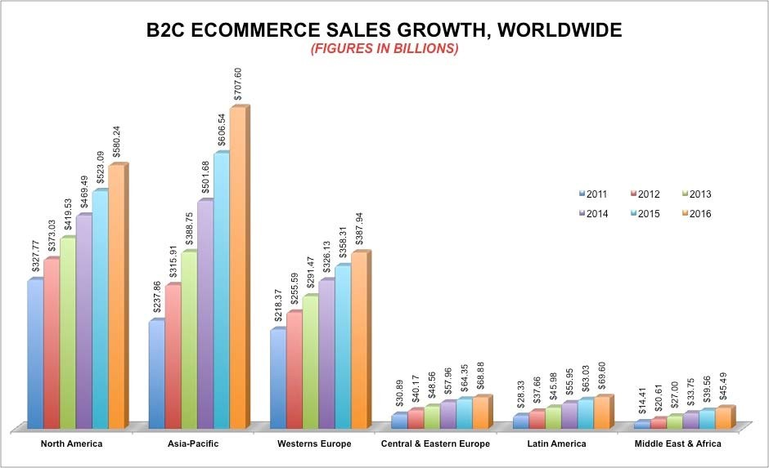
The Internet started to become popular among the general public in 1994, it took four years to develop security system such as HTTP and DSL, which increased access and Internet speed. In 2000 a large number of companies in US and Europe started their services in the World Wide Web. During this time, the general public began to learn about it as process of buying and selling goods and services over Internet using electronic payment methods using secure connections. The history of ecommerce is incomplete without Amazon and EBay, which were among the first Internet companies with facility of electronic transactions. By the end of 2001, Business-to-Business (B2B) model form of ecommerce had around $700 billion in transactions. E-commerce has emerged as one of the biggest Internet technology in the last decade. The comfort of trading or facilitating services using Internet has revolutionized the way shopping is done. The global growth chart is shown in Figure 2.

Figure 2 – B2C E-commerce sales growth worldwide
Market Size and Growth of e-Commerce in India:

India’s e-commerce market was worth about $3.8 Billion in the year 2009, it went up to $12.6 Billion in 2013. In the year 2013, the e-retail segment was worth US$ 2.3 Billion. About 70 per cent of India’s e-commerce market is travel- related. India has close to 10 Million online shoppers, and is growing at an estimated 30 per cent CAGR vis-à-vis a global growth rate of 8 to 10per cent. The main reasons for its growth are busy lifestyles, urban traffic congestion, lack of time for online shopping, lower prices compared to brick and mortar retail driven by disintermediation and reduced inventory and real estate costs, increased usage of online classified sites, with more consumer buying and selling second-hand goods, evolution of the online marketplace model with websites like Jabong.com, Flipkart, Snap deal, and In - beam respectively.

According to Report by Avendus Capital, entitled “India Goes Digital”, the Indian e- tailing industry is estimated to grow to Rs. 53,000 Crores ($11.8 Billion) in the sales, a feat it has managed to achieve before its own target (2015).

A report recently published by the Boston Consulting Group also stated that online retail in India could be an $84Billion industry by the year 2016 more than 10 times its worth of the year 2010. The growth in Indian market is shown in Figure 3.

(https://www.worldwidejournals.com)

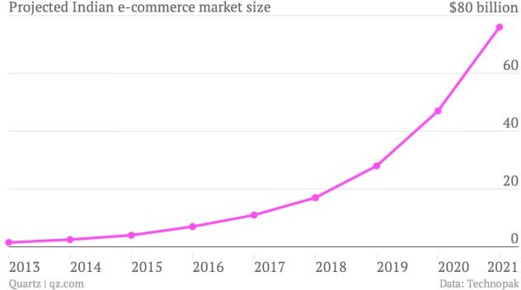

Figure 3 – E-commerce market growth in India

E-commerce business categories

There are four principal categories of e-commerce:

    - B2B (Business to Business) - It involves companies doing business with each other. For example when a manufacturer sell to distributor or wholesaler selling to retailer.

    - B2C (Business to Consumer) - It consists of companies selling to the general public through websites, without needing any human interaction. Example Amazon.

    - C2B (Consumer to Business) - In this model, consumers post a project with a set budget online, and companies bid on the project. The consumer reviews the bids and selects the company. It is similar to tender process

    - C2C (Consumer to Consumer) - This takes place through online ads, forums where individuals can buy and sell their goods. Examples E-Bay.

Technologies

The e-commerce technologies include:
- Mobile commerce
- Electronic funds transfer
- Supply chain management
- Internet banking
- Online transaction processing
- Electronic data interchange
- Inventory management systems
- Automated data collection systems

E-commerce businesses include some or all of the following:

    - Direct sales of good through online shopping websites
    - Platform for third-party (business-to-consumer or consumer-to-consumer) to do business.
    - Gathering demographic data through websites and social media.
    - Marketing to customer by e-mail or social media.
    - Electronic data interchange in business-to business.
    - Launch of new product by companies.

Transaction security

Security is a crucial part of any online transaction over the Internet. Customer will lose confidence in e-business if its security is compromised and can damage company image. For safe e-payments these are the important requirements:

- Confidential – Accessibility to information should be available only to authorized person. It should be secure during transmission.
- Integrity – No alteration to information during the transmission over the Internet.
- Availability – Information should be available as per requirement within the specific time limit.
- Authenticity – A system should be in place to authenticate user before it give access to the required information.
- Non-Repudiabiity – It is protection against denial of payment or order. Once a sender sends a message or recipient receives a message, they should not be able to deny the message.
- Encryption – Authorized user can only do Encryption and decryption of information.
- Auditability – Storage of data should be done in such a way that it can be audited for integrity requirements.

Security Tools

- Encryption – It is a very effective and practical way to secure the data transmission over the network. Information sender encrypts the data using a secret code and only specified receiver with the same or different secret code can decrypt the information.
- Digital Signature – It is an electronic signature authenticated through encryption and password. It help in ensuring authenticity of information
- Security Certificates – It is a unique digital id used to verify identity of a
user or website.
- Secure socket layer (SSL) – It is the most widely used protocol across the industry. It fulfills the following security requirements:
  - Authentication
  - Encryption
  - Integrity
  - Non-reputability

In Internet browser where user type the website name “http” represents: "http://" - With SSL
"http:/" – Without SSL
- Secure hypertext transfer protocol – It act as an extension to HTTP with additional features such as digital signature over the Internet. It acts as additional feature to secure HTTP to provide security to end-users.
- Secure electronic transaction – It is a secure protocol developed jointly by MasterCard and Visa. It is the considered the best security protocol. It has following elements:
  - Cardholder's digital wallet software – It allows cardholder to make secure purchases online using funds in the mobile.
  - Merchant software – This software helps in secure communication between customers and financial institutions.
  - Payment gateway server software – It provides automatic and standard payment process and it also support processing of merchant’s certificate request.
  - Certificate authority software – This software is used by financial institution uses this software to issue digital certificates to cardholders and merchants. It enables them to register their account for agreements for safe e-commerce.

Impact of E-commerce

Social

The e-commerce has affected the society and economy in a large way. The success
of e-commerce has led to emergence to many other services such as online banking, education, advertisement etc. Its rapidly growing business around the globe reflects how big its impact on the society and economy. It leads to lower cost, new employment opportunities and also improves the economic efficiency. Internet shopping has provided value to customers as now they can find and buy the best product in the market; compare prices in the global market to get the best value for their money. E-commerce companies also provide the best level of service compared to retail shopping, which earned them customer trust. In beginning people were unsure about using their credit and debit card details online for payment on e- commerce websites but with introduction of new IT services which are safe and secure and new laws related to e-commerce, customers confidently started using e- commerce websites.

Due to these factors, society has been affected by e-commerce

      - The importance of time has changed in today world. Customers today need convenience and fast service. It has changed the way people do shopping.
      - Distance has become irrelevant because of e-commerce. Now customers from rural part of the country are not required to go big city to purchase its good.
      - Easy return policy has changed the customer perspective. Customer who previously faced problem in offline retail stores to get back return or change their products is attracted to e-commerce because of it.
      - Highly competitive pricing has helped in adding more and more customer under e-commerce cloud.

Supply chain management

The companies have been long troubled on how to deliver supply chain technologies benefits to customers. However, the emergence of e-commerce has provided them a practical and effective way of delivering the benefits of the new supply chain. E-commerce has the power to incorporate department of inter- company and intra-company, which include physical, financial and information flow. The physical flow improved the inventory management for companies. The information flow has improved information processing and financial flow has allowed companies to have more efficient payment gateways.
The other ways in which e-commerce affects the supply chain management is:

Cost Factor

E-commerce has enabled exchange of cargo documents electronically over the Internet. It has allowed shipping firms to streamline documents by eliminating traditional document delivery systems. It resulted in less time and made the process easy and effective.

Companies with the use of e-commerce can reduce costs; streamline business process and provide better customer service. Exchange of documents such as freight invoices, shipping instruction etc. is done electronically, which resulted in higher accuracy and efficiency. The only investment is a personal computer and an Internet connection.

Distribution system

With millions of goods movement and huge information transfer between suppliers and customer, E-commerce provides flexibility in managing it. Customer can directly manage information throughout the supply chain thus eliminating contact between customers and distribution centers.

E-commerce has given businesses more flexibility in managing the increasingly complex movement of products and information between businesses, their suppliers and customers. Customers are always in loop during complete movement.

Shipment tracking

Customer can establish an account on e-commerce websites and obtain real time information about individual shipments. They can also view freight charges, claim in case of failed delivery and many other functions. The application uses encryption technology to keep customer information safe.

Shipping notice

The shipping items details are electronically transmitted ahead of the shipment. It
helps companies to record the details of every parcel being shipped.

Shipping Documentation and Labeling

The standard billing labels, shipping labels and carrier information are automatically produced thus reduced the need for manual intervention. With less paper work involved it makes shipping process more efficient.

Online Shipping Inquiry

The shipping information can be access to anyone in the company, from any location. The shipment is tracked accurately and proof of delivery is quickly confirmed. A customer can analyze shipping rates and negotiate for better deal thus helping in improving customer satisfaction.

Factors affecting E-commerce

IT and Security

One of major factor affecting e-commerce all around the world is security of online data. Ensuring safe payment online is key to acceptance of e-commerce. The lack of transparency in electronic payment and virus, spyware increases fear among the customers. The huge customer information with companies is always at risk and susceptible to stolen by hacker, co-operate spies and even employees.

Customer attitude

Globally, many customers still prefer to shop outside because they cannot touch and feel the product. Some customers are also impatient to wait to receive the product while some are not sure of the product quality. Some customers are still hesitant to put their banking, credit card detail online.

Technology

The technology changes very rapidly and its need to updated frequently to remain competitive. Companies continuously need to find new investors to invest in the
upgradation of new technology plus hire new IT profession to keep system performing at an optimal level.

Internet
Internet penetration is still very low in developing nations. In India with a population
1.2 billion people has estimated only 15.3% Internet users by 2013. E-commerce business depends on speed and bandwidth for communications. Broadband connection is still limited to urban and suburban area. Internet is out reach for rural population.

Infrastructure

Poor infrastructure acts as a hurdle for e-commerce companies to do business effectively. Poor connectivity to some part of the country limits their business area. Even though, a lot has improved but the delivery of goods safely in the hand of customer at right time still persists.

Others

  - Lack of IT knowledge to purchase online
  - Banking facility still eludes large population India
  - Reluctance of old generation to switch to e-commerce
  - Complex taxation laws
  - Right to e-consumers is still an issue
  - Complex websites interface sometimes make customers tentative to shop online

Government Policies

The e-commerce is governed by IT act 2000 in India. India was the 12 nations to adopt cyber laws. Some of the objectives of the act are:

    - To provide legal recognition for money transactions using electronic commerce.
    - To lay guideline for new e-commerce companies.
    - Attribution, acknowledgement and dispatch of electronic records.
    - Regulation of certifying authorities
    - Digital signature certificates
    - Duties of subscribers
    - Penalties and adjudication
    - Offences
    - Secure electronic records
    - Regulatory authority

FDI (Foreign Direct Investment) - is a controlling ownership in a business enterprise in one country by an entity based in another country.
In another words, FDI is an investment made by a company based in one country into a company based in another country. The investing company can make its investment overseas in three ways:

- By setting up a subsidiary or associate company in the foreign country.
- Joint venture or merger.
- Acquiring shares of an overseas company.

Types of FDI

- Horizontal FDI arises when a firm duplicates its home country-based activities at the same value chain stage in a host country through FDI.

- Platform FDI Foreign direct investment from a source country into a destination country for the purpose of exporting to a third country.

- Vertical FDI takes place when a firm through FDI moves upstream or downstream in different value chains i.e., when firms perform value-adding activities stage by stage in a vertical fashion in a host country.

Currently, there are two ways in which FDI can entry in e-commerce in India.
- Automatic Route
- Government Route

The guidelines for the FDI in India are as follow:

- 100% FDI under automatic route is permitted in marketplace model of E- Commerce.

Marketplace model – when an E-Commerce company provides an information technology platform on a digital and electronic network where the company acts as a facilitator between buyer and seller.

Inventory model – when an E-Commerce activity where inventory of goods and services is owned by E-Commerce entity and is sold to the consumers directly. The difference is shown in Figure 4.

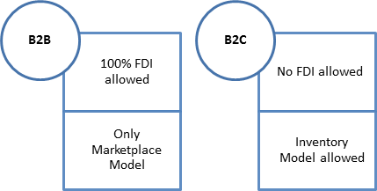

Figure 4, Government restriction in FDI in India (Source - http://dipp.nic.in)

- No FDI is permitted in the Business to Consumer ("B2C") E-Commerce, except in the following circumstances:

  - A manufacturer will be permitted to sell its manufactured products in India through e-commerce retail.

  - A single brand retail entity operating through brick and mortar store is permitted to undertake retail trading through e-commerce.
  - An Indian manufacturer is permitted to sell its own single brand products through E-Commerce retail. Indian manufacturer would be the investee company, which is the owner of the Indian brand and which manufactures in India, in terms of value, at least 70% of its products in house, and sources, at most 30% from Indian manufacturers.

- Goods/services made available on the marketplace website are to clearly provide the name, address and other contact details of the seller who shall be solely responsible for - delivery of goods, their warranty/guarantee and customer satisfaction subsequent to the sale and the warrantee/guarantee of the goods/services sold.

- Payments for such sale may be facilitated by the E-Commerce entity to the seller in conformity with the guidelines of the Reserve Bank of India.

- E-Commerce entities providing marketplace will not directly or indirectly influence the sale price of goods and services and shall maintain level playing field.

- An E-Commerce entity cannot permit more than 25% of the sale affected through its marketplace, from one vendor or its group companies.

Logistics

Overview

Logistics can be defined as the process of planning, implementing, and controlling the efficient, cost effective flow and storage of raw materials, in-process inventory, finished goods and related information from point of origin to point of consumption for the purpose of meeting customer requirements.

Logistics is happening around the globe 24 hours a day’ through a year. In some areas of business it involve the complexity or span the geography typical of logistics.
Logistics deals with delivery of products and services where they are needed whenever they are desired.
In case of physical goods, logistics involves integration of warehousing, packing, transportation and information flow.

Logistics can be of two natures:

      - Inbound logistics – is the process of logistics focusing on purchasing and arrangement of the inbound material, parts etc from suppliers to warehouses, assembly plant or retail stores.

      - Outbound logistics – is the process of storage or movement of finished goods from warehouses or assembly plant to the end customers.

The main areas of logistics can be distinguished as follows:

Procurement Logistics

- Distribution Logistics

After-sales Logistics

- Disposal Logistics

Reverse Logistics

- Green Logistics

Global Logistics

- Domestics Logistics

Concierge Service

- RAM Logistics

Asset Control Logistics

- POS Material Logistics

Emergency Logistics

- Production Logistics
Some of them are defined below:

- Procurement Logistics – It consists of activities such as market research, requirements planning, make-or-buy decisions, supplier management, ordering, and order controlling.

- Distribution Logistics - It consists of activities such as delivery of the finished products to the customer, order processing, warehousing, and transportation. It is important because the time, place and quantity of production and consumption differ.

- Disposal Logistics - It consists of activity of disposing waste produced during the operation of a business. It helps in reduction of logistics costs and improvement in services.

- Reverse Logistics – It consists of operations in which product and material are reuse. It also include sale of product that are returned from buyers. It is the process of moving good from its final destination to proper disposal.

- Green Logistics – Its aim is to minimize the ecological impact of logistics movement. It can be achieved by better freight transport, path optimization etc.

- RAM Logistics – It deals with the heavy business and military logistics. It is highly complicated because it deals with weapon systems and other military hardware.

- Asset Control Logistics – It deals with the transportation of assets required for promotional display and preservation. E.g. Poster frames, Display screens.

- Emergency logistics – It deals with the transportation of time critical good in case of emergency. The reason for it in any company can be due to many reasons such as production delay, natural calamity etc.

Logistics evolution
Material Management
Physical Distribution
Finished goods Inventory
Industrial Packaging
Material Handling
Warehousing Logistics
Manufacturing Inventory

The logistics evolution is explained in the Figure 5.

Fragmentation Evolving Integration Total Integration 1960 2000

Demand forecasting
Purchasing
Requirement Planning Materials
Production Planning Management

Order Processing
Transportation
Customer Service

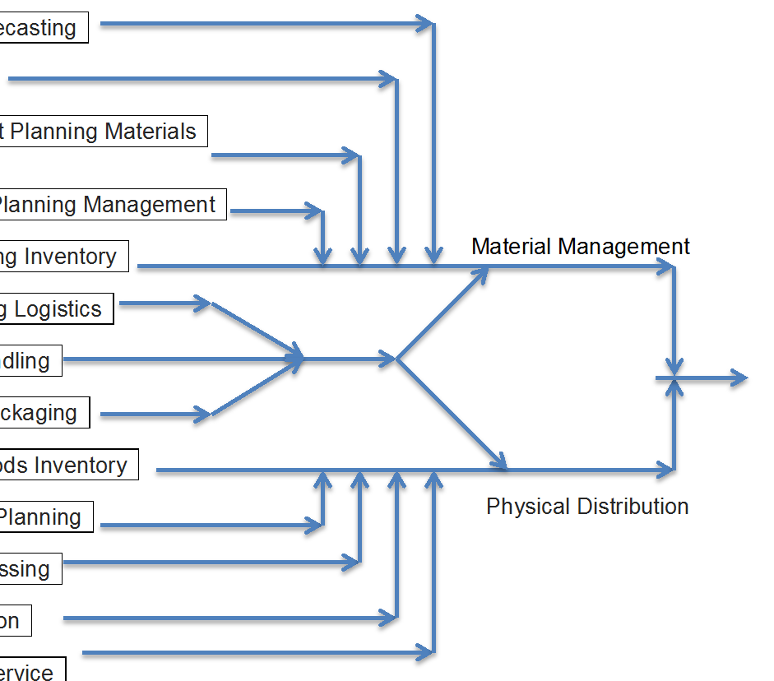
Figure 5. Evolution Logistics (Source - http://www.slideshare.net)
Distribution Planning

Fragmentation 1960:
This phase was known as fragmentation because each part was disintegrated and done separately.

Evolving Integration:
During this time the concepts of Logistical management was evolving.

Total integration
In the present day scenario, Logistics has evolved to become a part of management.

Importance of logistics

Logistics has gained importance due to the following developments:

      - Rise of transportation cost due to the rise in oil prices.
      - Production efficiency was almost maximized.
      - Change in inventory concept in business
      - Product line proliferated.
      - Rise of computer technology.
      - Products growth led to opening of new, large retail chains or mass merchandisers with large demands. Sophisticated logistics services overtook traditional channel & distribution.
      - Relaxation in economic regulation globally.
      - Increased power of retailers.
      - Globalization

OBJECTIVES

Companies or firms in terms of logistical system design and administration must achieve at least six different operational objectives to be efficient.

Rapid response

It deals with a firm’s ability to satisfy customer’s service requirements in a timely manner. Nowadays, logistics operation with the help of Information technology can be postpone at the last possible moment. It is then fulfilled by rapid delivery of required inventory. It helped in removing excessive inventories, which are usually stocked in anticipation. It shifts the operational emphasis from an anticipatory inventory stocking of material based on forecasting to responding to customer requirements on a shipment-to- shipment basis.

Minimum Variance

Variance is any unexpected event that disrupts system performance. Variance may result from any aspect of logistical operations such as delays in expected time of customer order receipt, an unexpected disruption in manufacturing, damaged good arriving at a customer's location, or delivery to an incorrect location. All result in a time disruption in operations that must be resolved. Potential reduction of variance' relates to both internal and external operations. The traditional solution to this problem was to establish safety stock inventory or use high-cost premium transportation. Such practices were expensive and risks related with it have been replaced by using information technology to achieve positive logistics Control. Minimized variances increases logistical productivity, which results in economic operations.

Minimum Inventory

The objective is to reduce inventory to the lowest level in level with customer satisfaction to achieve the lowest overall total logistics cost. Concepts like zero inventories have become increasingly applied as managers seek to reduce inventory deployment. Zero inventories concept looks economical but inventories have it own benefits. In large-scale manufacturing and procurement, it provides better return on investment. The objective is to reduce and manage inventory to the lowest possible level while simultaneously achieving desired operating objectives.

Movement consolidation

Major logistics cost involves transportation. Transportation cost is directly related to the type of product, size of shipment, and distance. Premium transportation, which offers faster delivery, depends on high-speed, small- shipment transportation. Cost of premium transportation is higher. To reduce transportation cost it is desirable to achieve movement consolidation.

General rule in transportation is - larger the overall shipment and the longer the distance it is transported, the lower the transportation cost per unit. To
achieve it, computers and transportation programs group’s small shipments for consolidated movement. Such programs must be facilitated by working arrangements that transcend the overall supply chain.

Quality improvement

The fifth objective is to seek continuous quality improvement. Industries in every sector are now moving toward Total quality management (TQM). Logistics cannot add any value if the product is defective or service quality is poor. Logistics costs are usually irreversible. As quality fails, the logistics performance also reduces due increase reverse logistics. Logistics operations are performed over large area every day. It increases challenge of achieving zero defect logistical performance. Redrafting of a customer’s order because of imprecise shipment or in-transit damage is far more costly than performing it right the first time.

Life-Cycle support

The last objective is life-cycle support. Products are mostly sold without some guarantee that the product will perform as advertised over a specified period. Product recall under some conditions is part of reverse logistics. With high quality standards, product failure under guarantee can be reduced. It also includes responsibility for hazardous consequences in case of product failure under expiry date. Laws prohibiting disposal and encouraging recycling of beverage containers and packaging materials are taken under consideration in return logistics. The commitment to life cycle support in case of firms marketing consumer durables or industrial equipment is very demanding in case of operational requirement and complex. It also has the largest costs of logistical operations.
(Chaudhary)

Logistics in e-commerce

Logistics in e-commerce is different as compare to traditional retail logistics. In conventional retail customers from shop or showrooms pick goods. Suppliers are in direct contact with retailers. In case of e-commerce, goods are delivered to
customers using means of transport such as rail, air etc. It also sells goods from 3 parties. The flow can be better understood through Figure 6.

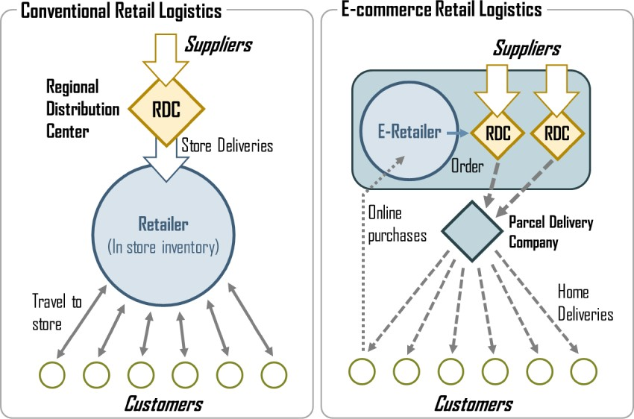

Figure 6. Difference between conventional and e-commerce retail logistics

In relation to e-commerce, logistics fields are as follows:

- Procurement logistics – It consists of activities such as make or buying decision, sales forecast, order controlling, supplier management, market research. The main aim is to minimizing procurement cost and maximizing efficiency.
- Distribution logistics – It involves delivery of finished goods to the customer. It consists of order processing, warehousing and transportation. It is important with respect to e-commerce because consumption differs with time and place.
- Disposal logistics – It involves disposal of waste material during the operation of a business. The main aim is to minimize logistics cost and improve efficiency.

Handling and order processing

Handling system include many equipment such as multiple handler, cell racks, cantilever racks etc. Order processing involves labeling, weighting, packing, lading
bills, picking order for transportation etc. Picking is done manually and automated. In manual, use of conveyor belt is used for good movement and picking by man. Robots or dispensers are used in automated case. Sorting is done manually or through automated sorters.

Storage racks

In warehouses, the items are stored in proper arrangement. It is done with the help of storage racks.
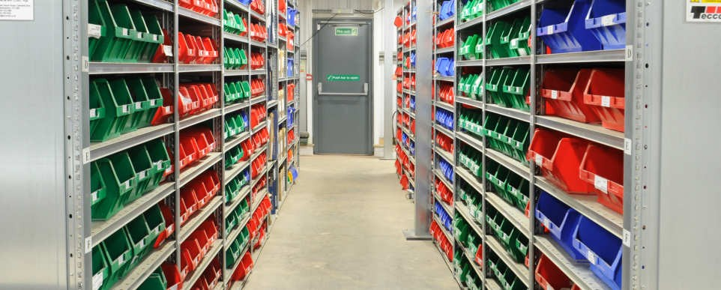

Figure 7. Storage Racks

Automated picking robots

Automatic NC (Numeric Control) picking robots are used to pick items which has to be shipped. The process is monitored by warehouse staff that moniter and control it via computers. Picking and packing process is quick due use of machines and less human involvement reduces error in picking.
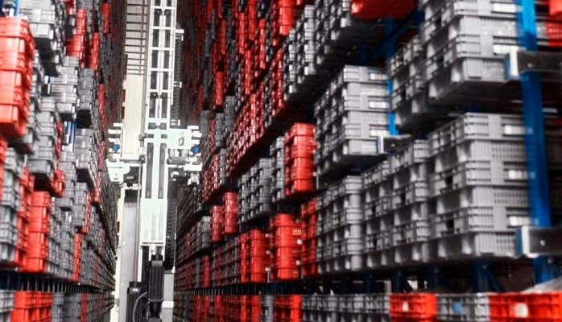

Figure 8. Automated Picking Robots

Picking through use of conveyer belt

Shipping items are moved in packing facility with the help of conveyor belt. Items are then packed in boxes based on its size then they separated based on delivery locations.
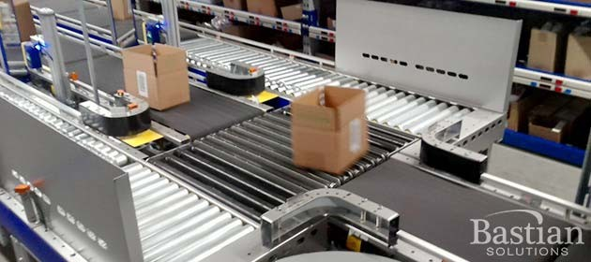

Figure 9. Conveyor Belts

Weighing machine

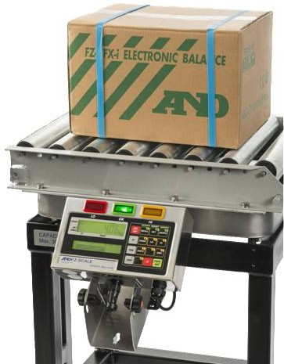

Figure 10. Digital Weighing Machine
Packed shipping items are weighed using Digital Weighing Machine. Items shipping cost is directly related to shipping weight.

Transportation

Goods transported from warehouses are moved through variety of transported medium such as bus, train, airplanes and ships according to volume and weight. Freight charges depend upon the mode selected. Air services are the most expensive one but is the fastest. Special containers and loading blocks are used in order to prevent good damage during transit.

Outsourcing

Outsourcing is basically means if a company with its own warehousing facilities decides to employ external transportation, would be an example of Outsourcing. Outsourcing is done either completely or partial. Partial outsourcing is usually done for specific location or time. This is very safe and cost effective way for small companies who do not have capital or sales to start its own logistics branch. Big e- commerce companies with high volume sales such as Flipkart and Amazon usually have its own logistics arm to support its operation.

The decision outsource to a Third Party Logistics (3PL) company can be challenging yet rewarding to the organization. Supply chain functions have grown increasingly
complex with globalization, technology, and competition advancing at a rapid pace. Analysis of cost factors, performance gaps, financial impact, and suitability for outsourcing yields is required for superior outsourcing strategies and transition plans.

Case one – Amazon India

Introduction

Amazon is an American electronic commerce company with headquarters in Seattle, Washington USA. Jeff Beroz founded it in 1994. It started as an online store but later diversifying to sell CD, software, electronics, furniture etc. The company also produces consumer electronic goods such as e-book reader – Amazon kindle, TV etc. It is world’s largest e-commerce company currently and conducts business in 10 countries:

- U.S.
- Canada
- UK
- Germany
- France
- Italy
- Spain
- Japan
- China 10 India

In 2013, Amazon launched its site in India, amazon.in. It started with electronic goods and expanded into fashion apparel, beauty, home essentials, and healthcare categories by the end of 2013. Since India does not allow foreign direct investment (FDI) in direct online retail, Amazon started by launching Junglee.com. It is a price comparing website completely own by Amazon. On Amazon’s marketplace in India, users can buy books, movies and TV shows from independent sellers directly on Amazon.
Amazon is known for its wafer-thin margins, but still reported sales growth of over 27% to $61 billion in the year 2013 in India. It push back much of the money it makes into the company. By 2015 end, Amazon started operation in 50 cities. It projected to grow rapidly in the next five years. The Figure 11 shows the sales forecast.
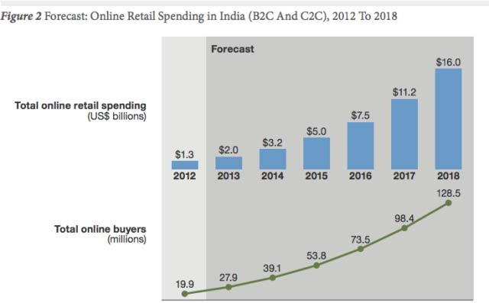
Figure 11. Sales forecast in India

Competition

Other major companies operating in Indian e-commerce market are:

    - Flipkart
    - Snapdeal
    - EBay

The market share of each company for the year 2015 is shown below

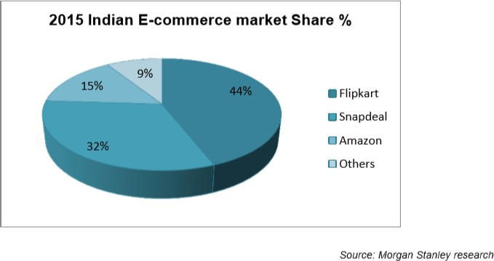

Figure 12. Indian E-commerce market share in 2015 Reasons for Amazon’s late entry
Amazon started its online marketplace in India from 2013. The company started with
software development centers, which has employed many software developers and technologists’ through India. Amazon was not interested in India as a potential market due to the following reasons.

- The major reason that prevented Amazon’s entry into was due to political reasons. India liberalized its markets to foreign investment way back in 1991; the retailing sector was still closed to foreign retailers. FDI is not allowed inE- commerce. In last decade, Government of India introduced reforms that allowed foreign retailers like Amazon to partner with local partners to sell their products. Inventory based model on which company operates in US is prohibited in India.

- Secondly, the online retail market in India was too small in the early 2000. Economically, Indian market was not an interesting prospect

- Another important reason that discouraged Amazon entering India was that despite the country’s massive population, Internet penetration was very low in the country. India only had ~50 million active Internet users in the year 2012 which means that the potential customers in the country was too small.

- The concept of online retailing was not well established in India since people were more comfortable with traditional shopping methods. Amazon has to not only enter new market but also have to create awareness about online shopping. This additional cost would have affected the return on investment for the company.

- The poor infrastructure of India especially in logistics handling, technology and transportation in respect to size of the country was another problem. Even though it had big market for the future but the environment was completely different compared to US and Europe where Amazon currently operates.

Testing the waters

The massive success of local online retail businesses of Flipkart.com – a local online retail business started by a couple of Indian executives, evoked a lot of
interest of Amazon due to its successful adaption of many practices that were currently followed by Amazon in US. With higher GDP and growing economy, Internet penetration in India is expected to grow substantially in the next decade. According to conservative estimates, the Indian online market is expected to reach
$8.8 billion by 2016.
With Indian economy moving toward more free market economy, Amazon has to establish a presence early in order to capture market share organically. Successful implementation of marketplace model by Flipkart has given huge opportunity to Amazon to replicate the marketplace strategy that it adopted during the early 2000s in US.

Services

Selling on Amazon

All type of business can sell product and services on Amazon. It is one of the fastest ways to begin selling online

- A source of new sales channel to businesses
- It help in building brand recognition
- A trusted and secure platform is provided by Amazon

Fulfillment on Amazon

- Amazon helps companies to sell their product online globally
- Access to prime customer of Amazon
- Trusted customer sales and after sales service
- Amazon offer fast, reliable shipping to customer

Advertisement on Amazon

- Reach to millions of Amazon customer
- It helps in driving more traffic to your website
- Amazon helps businesses to advertise their product online

Business process and model

The business process in e-commerce is quite similar to traditional retail store business. The e-commerce business can be divided into 6 parts

    - Sourcing - Acquiring goods from the seller to store in warehouses
    - Cataloging - Taking pictures of items acquired
    - Listing - Uploading pictures on websites
    - Marketing - Advertising its website to attract customers to its website to purchase
    - Packaging - To pack sold items for shipping
    - Shipping - Delivery the item to the customer

Business model
These are of two types

- Marketplace model – In this model e-commerce companies only act as a platform for seller to sell. Due to foreign direct investment restriction in India in which foreign companies sell items directly to buyers. Amazon in India is working on this model currently.

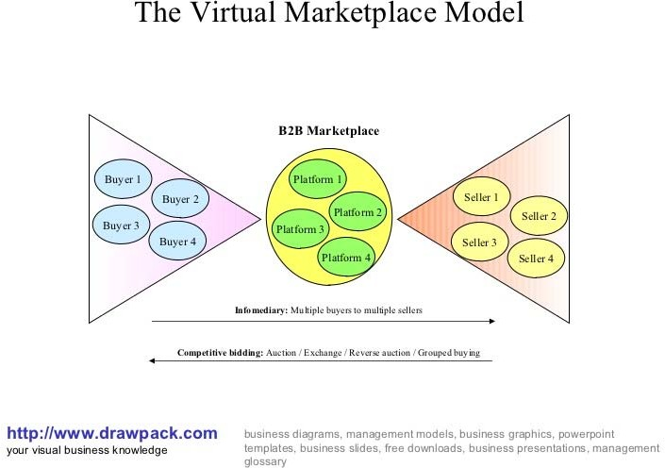

Figure 13. Market place model

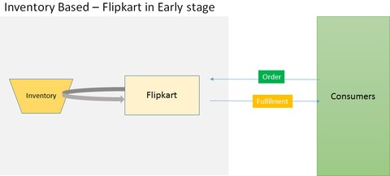
- Inventory model - In this model, e-commerce companies’ purchase item to building inventories and store them in warehouses. It then sells directly to the buyer.
Figure 14. Inventory based model

Amazon Logistics structure and Operation

Ordering

A customer after opening the website, select one or more items for purchase. This items directly goes to the electronic basket provided by websites. It provided information about pricing, delivery time and payment mode such as credit card, online banking etc. Sometimes based on the customer history option of cash on delivery, discounts are roled out to customers.

In case of Business to business tranctions, a separate system is placed to keep record of order history and according to it several discounts and concession are offered to them. The inbuilt software will check all taxes, payment terms and delivery. Order will be cleared only after it is technically and commercially clear and the same will be confined to the client electronically.
Ordering process is crucial in an e-commerce company as it involves setting up the system standard to meet customer requirement. Order is processed in batches according to volume of inflow on an hourly or daily basis.

Inventory management

Inventory management has played a vital role in e-commerce business. The mismanagement can seriously affect your profit and reputation. Some of the ill effects of a poorly manage inventory are as follow:

      - Reduce cash flows
      - Delayed shipment
      - Process bottleneck due faulty forecasting and data entry
      - Negative customer experience
      - Inconsistent sales growth

Amazon has integrated inventory online order with order planning, inventory planning and fulfillment system. In case the item is not in stock or under processing, its delivery time will be confirmed to the customer before the order is accepted. Its inventory management system closely monitor the inventory movement right from the source of supply, warehouses, distribution center and finally to customer. It uses computer software and algorithm to forecast sales and inventory. For items out of stock, replenishment instruction will be issued as soon the item is off the shelves.

The main objectives of Amazon inventory systems are:

- To clearly understand customer delivery need.
- To coordinate with the wholesale suppliers and independent seller to make customer available to customers both current and soon to be released products.
- To provide delivery under two days for most orders.
- To enable customer to query the status of their product and track their own shipment.
- To align supply and delivery with other operations such as marketing, customer service.
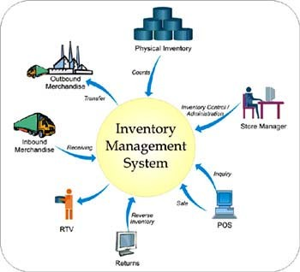

Figure 15. Inventory Management System

For Amazon, in order to ensure that all orders can be processed and shipped in time for Diwali and Holi (two biggest festival in India), when sales volume is at its peak, the company employs a variety of data collection tools to make sure purchased goods move through from warehouses onto trucks as quickly as possible.

Order execution

Once the order is accepted for execution, order details are passed on to the inventory manager or directly to the third party for filling and packaging. The order details incorporate item detail, quantity and packaging. The warehouse manager will then instruct for delivery of item to the customer. All this process is done
electronically. The delivery detail will be immediately conveyed to the customer via email and SMS along with the invoice.

Shipping

Based upon the size of the consignment, transport is organized by the logistics arm of Amazon or through third party logistics partner in some case. Decision software decides the choice of carrier, mode of transport, route, scheduling of goods according to client location, public holidays and other variables.

Amazon Drones And Other Innovations:

It is a recent buzz according to which Amazon is busy building or has probably built drones to increase its business. Sooner or later, drones will be acting as local delivery boy and will be delivering goods at customers’ footsteps and giving online retailer ship just an- other level. So, customers’ do not have to worry too much anymore whether the person delivering goods to your address is confused at how to find your address. Who knows? Maybe Amazon someday makes it possible. A customer wishing to get delivered a set of books merely has to locate his house on Google maps, and paying machine comes with the stuff you ordered.

Tracking

Customer always wants to know the current status of item during transit. To help in locating the consignment, a bar coding system with satellite communication is used. Amazon provides this code to the customers on its websites to help them locate their order. It is a value added service for customer convenience.

Payments

Amazon provide customers many payment option such as:

      - Credit card
      - Debit card
      - Online banking
      - Cash on delivery
      - Coupons
      - Paypal

Some options such as cash on delivery sometimes depends upon client location, credit history, item value and volume of order. The system then generates online invoices, payment report, payment reminder etc.

Order cancellation and substitution
In case of order is cancelled by Amazon due to some reason beyond management control, it informs customer in time via email and phone. It also gives customers substitute option available to them. With years of operation it has evolved it order cancellation policy to maintain the customer trust.

Return policy

In a case where customer does not like the product, find performance below expectation or product being damaged during transit. For items fulfilled by Amazon, will be eligible for a free replacement. A detail timeframe and guideline for return is given at Amazon website.

Return process
A separate system in place handles the reverse material flow. The return process is shown in Figure 16.
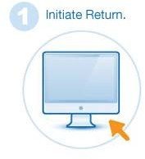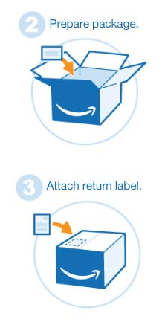

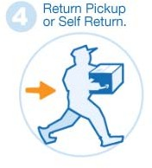

Figure 16. Return Process

Logistics system in Amazon India

Amazon started delivering goods using third party logistics. It was cautious move because they were entering into a completely new market. With increase market share and revenue, it started its own logistics branch to handle its logistics operations.

The reason behind launching its own logistics branch is as follows:

      - Cost saving.
      - Reducing the amount of damage good delivered to customers.
      - Better customer service.
      - To build its reputation as safe and reliable company.
      - Optimization of supply chain.
      - Ability to collect data and analyze it for further improvement.
      - Delivery of goods on time and to right person.

Case Two - Flipkart India

Introduction

Flipkart is an e-commerce company based in Singapore. It was founded in 2007, by Sachin and Binni Bansal who were the ex-employees of Amazon.com. it operates in India. According to alexia internet, Flipkart is one of the most popular website visited in India.

Legally, Flipkart is not an Indian company since it is registered in Singapore and majority of its shareholders are foreigners. Because foreign companies are not allowed to do multi-brand e-retailing in India, Flipkart sells goods in India through a company called WS Retail. Other third-party sellers or companies can also sell goods through the Flipkart platform. Flipkart now employs more than 15000 people. Initially in 2008 Flipkart sold books but soon it established itself wide and started selling products like consumer electronics, clothing, home decoration products, appliances, beauty and fashion products etc. Due to the powerful network all over India and effective customer relationship management, Flipkart has earned a top most position in India.
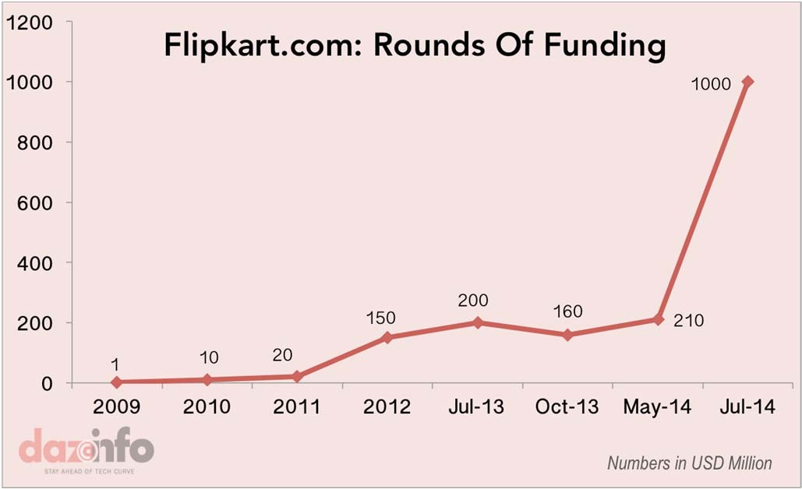

Figure 17 – Flipkart Funding
Flipkart sales and revenue overview:

Average Shipments a day - 1,00,000
Current Annualized Revenue - 33.55 billion INR Valuation – 99 Billion INR
Revenues 2012-13 - 11.80 billion INR Revenue Target for 2015 – 61 billion INR Customers - 10 million
Cities - 150

(INR = Indian Rupee)

Business model

Flipkart started on inventory based model and currently operates on both inventory and market place model Since 2013, Flipkart has been slowly shifting to a marketplace model, where it connects customers to thousands of third-party sellers rather than sell products only through WS Retail due to the new FDI rules in India.

“FDI is not be allowed in inventory-based models, where the company owns the goods that are being sold through its platform”

WS Retail – is the largest seller on its platform, and accounts close to 40% of the total sales of the company. As part of a complex arrangement, WS Retail sells goods from Flipkart India Pvt. Ltd, the B2B (business-to-business) arm of the main group holding company, and sells the same goods to customers on Flipkart’s site. WS Retail also owned and ran Flipkart’s key logistics business called e-kart that delivered products to customers.

Flipkart Logistics structure and Operations
Due to ban in FDI in online retail in India, Flipkart has a very complex interconnected with some independent firms. It transfers massive funds into these independent firms to build an interconnected e-commerce business.
Flipkart provides technology platform and logistics services to the manufacturers from whom it sources goods and then sells those goods to many of its third party sellers. These sellers then offer goods to shoppers. Flipkart takes a commission on every sale through its website. It does not operate in a pure marketplace model. It has a complex set of nine firms. It owns stakes in most of these firms. The major three firms, which are registered in Singapore as 100% subsidiaries of Flipkart are:

    - FPL: Flipkart Marketplace Pvt. Ltd
    - Flipkart Logistics Pvt. Ltd
    - Flipkart Payments Pvt. Ltd

These companies, in turn, hold stakes in five Indian firms.

- Flipkart India Pvt. Ltd
- Flipkart Internet Pvt. Ltd
- The wholesale cash-and-carry firm
- Digital Media Pvt. Ltd
- Flipkart Payment Gateway Services Pvt. Ltd

The reason behind the complex structure is FDI is barred in direct online retail in India.
The ownership of FPL Singapore is shared between Tiger Global, Accel Partners, Naspers and the Bansals. Tiger Global, the US-based firm holds approximately 30% in the parent company with two seats on the board. Flipkart also owns Myntra, a clothing e-commerce company that was acquired by Flipkart in May 2013 for $330 million.

Company Structure

The entire organizational structure of Flipkart is organized in three broad teams as shown in Table 2.

Product and Technology | Business Development | Operations
Website | Vendor Management | Procurement
Management ERP System | Sales Management | Warehouse
 | Pricing Strategies | Logistics
Customer Support Product and Technology
Team

Table 2 – Flipkart company structure

Product and Technology Team

It is the core team of the company which manages the company website and the ERP system. Website is a pillar for any e-commerce business. Flipkart has a modern system, which uses open source software. The team manages the process starting from listing of products to optimization of search.

Business Development Team

This team is responsible for activities related to sales, pricing, discount strategy, and vendor management.

Operations Team

This team is responsible for the supply chain. It include procurement, warehouse management and customer support. The customer support is done both online as well as offline.

Customer Support team

Flipkart put a lot of emphasis on customer service. It guarantees a 24/7 service to all its customers. It has a full time customer support team with two main responsibilities:

- Website Guidance – To assists new user on how to use website. It also assists users in case of payment enquiries, order verification calls etc.
- Delivery related guidance – It resolves and inform customers in case of late delivery, post purchase issues etc.

Logistics

Flipkart ships more than 100000 items per day, which makes logistics a very important aspect of the whole operation and also difficult to manage. To manage logistics Flipkart uses its own logistics arm known as eKart. The reason to have its own logistics arm is to save commission which usually around 2%, which it has to pay to courier firms. Around 60% of the total orders are delivered by eKart and rest is done by 3PL (Third-party Logistics). Flipkart has tie up with 15 courier companies such as Bluedart etc. More than 90% orders are shipped on COD (Cash on Delivery). It uses Post India only in case when its own service as well as 3PL cannot deliver in the particular area. In eKart, the item is first delivered to the main hub and then to the local delivery hub from where last mile delivery is done by suitable means of transport such as two-wheeler, foot etc. In case of 3PL, the company allocated time slots to different courier firms to pick up the items to make it efficient. Delivery cost in India is relatively low due to cheap labor availability. Delivery time depends upon the item and the location. If the item is imported then it usually takes 3 weeks to delivered. For items available in local warehouse, it takes 3-4 to deliver. Mode of transport depends if the item is to be delivered from local warehouse, it done by two wheelers or by foot. For trans zone, air cargo service is used. In case of intercity, Rail or bus services are used.

Reverse logistics / returns processing

Flipkart has 30 day return policy, which helps, in building trust with the customers. Usually return is around 2.6% of the total delivered items. A detail return policy is available to customers at Flipkart website. This logistics comes into play when the customer request one of the following:

- Replacement – When Flipkart returns the product to the supplier and delivers the replacement to the customer.
- Refund– When customer is not satisfied with the product and wants it money refunded. It can be done either online transfer or through cash on delivery payment.

Procurement

Flipkart started its operation by inventory model, in which it stores items from the suppliers in its own warehouses and buy only when it is sold to customer. The new laws in India are highly favored in marketplace model. Flipkart switched to it in April 2013. In this, it does not hold inventory from sellers rather than its seller directly sells to buyer and it only focus only on delivery. This model is similar to Amazon and many other e-commerce companies in India. The procurement is done for two reasons:

- Inventory – On the basis of previous demand, these items are stored in the warehouses by the sellers. These are fast consuming items and low shelf life such as mobile phones, electronics goods etc.
- Just in Time – These items are ordered to fulfill pending orders. These are highly unpredictable and depend on season. It is done on order-to-order basis. It is not very profitable because it for the expensive items with low sales and less discounts.

Currently, inventory based order is around 75% and just in time 30% of the total sales.

Sourcing at Flipkart

- Regional - Region procurement team
- Centre - Central procurement team

Each team has a big network of suppliers to fulfill both inventory based as well just in time procurement. Central procurement team monitors supplies from all over the country and it usually deals with bigger suppliers. It also monitors stock at regional level. It tasks it to avoid stock out which zero availability of product in the inventory.

Warehouse Management

Flipkart has 7 major warehouses in the country.
- Mumbai
- Kolkata
- Delhi
- Noida
- Pune
- Chennai
- Bangalore

It has regional distribution center around 500 locations in Tier 1 and Tier 2 cities. Flipkart’s Warehouse Management System (WMS) has three main parts:
- Inward Processing
- Storage Management
- Outward Processing. Discussed

Flipkart warehouse management systems are shown in Figure 18.
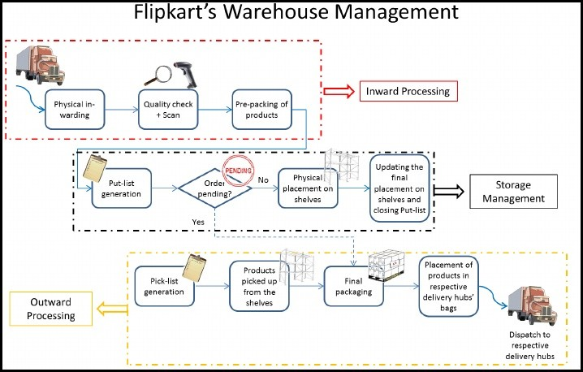

Figure – 18 Flipkart Warehouse Management Systems
Inward Processing

Physical inwarding:
Goods from suppliers are delivered to this area.

Quality Check plus Scan:
Once received, goods go through initial quality check and are scanned for entry into warehouse IT system as input of goods. Sometime quality is checked at supplier end depending on the contract between Flipkart and supplier’s.

Pre-packing of products:
Initial packing is done at this stage. It varies according to product and size. If there is free item is attached to product then it will be packed together.

Storage Management
Put-list generation:
After input of items is done the warehouse IT system, a system knows Put-list- generation, which marks place and shelve where the items need to be put.

Order pending check:
When the system get any input for the any product, it checks for any incoming item then the item is sent to the Final Packaging Area for Outward Processing.

Physical placement on shelves:
According to put-list, the items are placed at their designated shelf and its shelf number is updated on the put-list.

Closing of Put-list
Once the items are placed on the shelf, the put-list is closed.

Outward Processing Pick-list generation:
According to the order delivery time, a Pick-list is then generated by the system.

Pick-up from shelves:
The items are then picked from the shelves and are moved toward the packing area.

Final packaging:
The items are then packed into boxes. It varies according to the product. For eg electronic items are packed differently than books and bags. Then packed boxes are placed to the delivery hub, which is different according to the designation and timing.

Improvement at Warehouse Management level:

- The products are scanned manually at inward processing stage. Process can be speed up with automation at this stage.
- Currently at Flipkart, there are different storage areas according to the products. It decreases complexity of the system.

The customer email id is considered as the unique identification number for all the customers. It assists them in maintain records related to the ID.

Payment can be made by all kinds of means such Bank transfer, Credit card, Debit card, Cash on delivery. Cash on delivery is the most popular option in India and comprises for more than half of the total orders.

Order Fulfillment
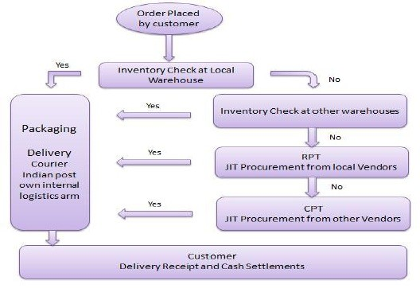

Figure – 19 Order fulfillment process
As shown in Figure 19, once the order is approved, there is an inventory check at warehouses. If the item is not found at the local warehouse then the inventory is checked at the nearest warehouse. Order is then packed for the delivery. In case it is not available in any warehouse then it is forwarded to the regional procurement team for JIT. In case it is not possible, then order is forwarded to the central procurement team as the final option. Once the item is procured from the vendor, it is packed and shipped to the customer.

Inventory Management

Inventory stocks are ordered once they go below reorder point. Flipkart uses FIFO (First In First Out) method for its inventory management. It works on the principle that for inventory shipment request for any warehouse, oldest items are to be shipped first. It is crucial especially in case of electronics as technology become obsolete very quickly. Flipkart uses “Long Tail” Concept to decide which item to be stored at warehouse and which items to be ordered from vendors. It works on the principle of selling large quantity of special items with small quantities. Flipkart order such item and do not store it since the demand for such items is low.

Supplier Management

Flipkart works on the policy of starting small and then build up when demand increases. It generally starts with local suppliers and once the demand reaches a certain point, they approach the bigger wholesale suppliers.

The advantages of it are:

- It helps them to negotiate better deals from bigger suppliers when they order larger quantities.
- It also helps bigger suppliers to reduce complexity when they have also agreement with other small online e-commerce companies.

Flipkart fhas divided its suppliers into groups based on their fill-rate performance and past performance.

Other secondary considerations while placing an order with a supplier:

Price considerations
Discount and credit limit plays a crucial role in selecting suppliers.

Quality Check contract
It depend upon the place of quality check whether at suppliers place or at Flipkart warehouses.

Percentages of Returns Accepted
Higher the returns accepted by a supplier, it’s better for Flipkart.

Customer Support

Customer support is one of the most important functions for any e-commerce. It helps in building customer trust and maintaining customer loyalty. Flipkart tries to differentiate with other competitors by offering superior shopping experience and by ensuring that order is placed within 6 clicks at their websites. It trains it team in house rather than outsourcing to maintain service quality.

Flipkart customer support team consists of center agents. Their primary task is to handle inbound and outbound calls. The customer calls due to following reasons.

- Sales Assistance
- General Enquiries
- Shipping related enquiry

The outbound call-center performs the following tasks:

- Informing customers about any delay in deliveries.
- Checking the status of refunds or returns.
- Inform the user in case any unsuccessful delivery.

Analyses

Cross analyses between Amazon and Flipkart

The some of the figures below compares Amazon and Flipkart in various parameters

Product offering

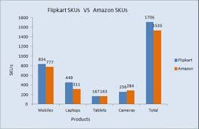
Figure - 20 Product Offering Comparison between Flipkart and Amazon (Source: www.econmictimes.com)

As the Figure 20 shows, Flipkart has more sales in mobile section. The gap is bigger in laptop section. Tablet and cameras section is very close.

Product portfolio and sellers

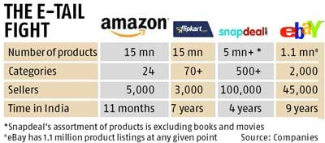

Figure - 21 Product portfolio of Amazon and Flipkart
In Figure 21, Flipkart has the edge when it comes to categories. It has more than 70 categories of product it sell on its platform as compare to Amazon which is 24. In case of no of seller, Flipkart lag behind Amazon by huge margin. The difference in number of seller between Amazon and Flipkart is 2000.

IT and social medial popularity

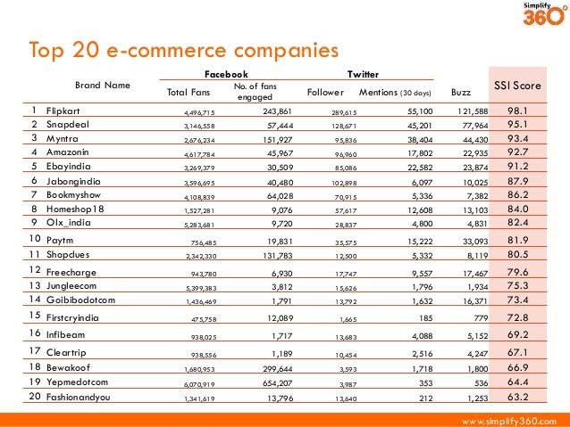
Figure - 22 Social Medial Popularity
.
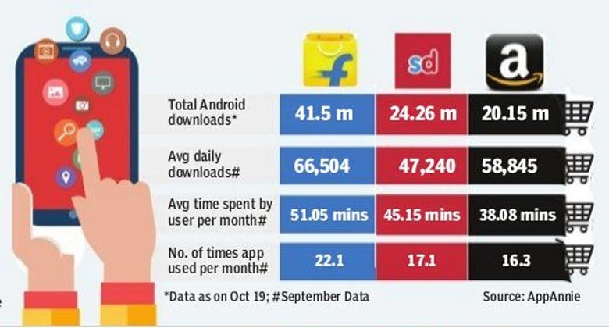

Figure - 23 Mobile download and daily usage (Source – AppAnnie)

The Figure 22 & 23 show, Flipkart is way ahead of Amazon in terms of social medial popularity. Flipkart entered the Indian market early, which can be a reason behind more popularity. Even with the late entry, Amazon with its efficient delivery system and shopping experience is catching up fast.

Net Revenue and Loss

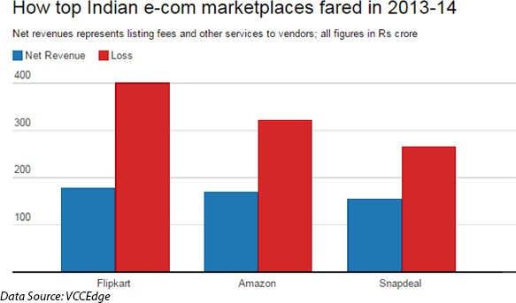
Figure - 24 Net revenue and losses (Source – VCCEdge)

In Figure 24, by comparing losses and net revenue shows that both these company are in loss. It is mainly because both these company is selling many items such as phones below retail prices. They do it by offering payment to third party seller to sell goods under price. Losses are much higher in Flipkart as compared to Amazon. It is mainly due to the fact of larger market share of Flipkart.

Promotional Techniques:

Promotional techniques of Flipkart

Flipkart advertise through print and electronic media which include newspaper, television etc. It mainly focus on the web base advertisement such as e-mail promotions with discounts offers.

Promotional techniques of Amazon

Amazon also do marketing through print and electronic media. It also uses web base advertisement using emails for promotional information with discount offers, networking but also promotes other popular websites for ads and tags promotions.

Delivery Manners:

Both the companies are different in the delivery manner. For e.g., if you order a book and a DVD. It may be possible that the delivery of book is done next day but DVD may arrive a few a later. It happens if the seller takes more shipping time.

In case of Flipkart, it is different. It ships the two items together in the same package. It will take more time for delivery due to it. It depends upon customers what kind of delivery system they like. Some might favour Flipkart delivery manner while other may like Amazon. Flipkart have this delivery manner because its cost saving. Amazon also saves its expenses by avoiding any intervention in the delivery process midway.

Amazon in India started the same day delivery system. It caters the need of those customers who are desperate to get their ordered products on the same day. It cost them some extra fee. Recently, Flipkart too started this service with same service but its fee is little less as compared to Amazon. This service has certain conditions such as order should be placed before 6 P.M.

Business Model - Flipkart & Amazon
Generally, the business model used by e-commerce companies are either inventory or Marketplace based.

Flipkart when started its on inventory based model. It invested huge capital on warehouses and logistics. Since 2013, it started using mixture of both models. It is mainly due to the FDI norms in India. Amazon on the other hand has always operated on marketplace model. In April 2016, Government of India allowed 100% FDI in marketplace based e-commerce. The operating condition after the announcement now favours heavy toward marketplace model. All the leading e-commerce companies are working under marketplace model.

Pricing Strategy

It is very often seen in the Indian market that both Amazon and Flipkart are offering the same price or very close price for some products. Both these companies are marketplaces and sellers may not necessarily agree to price cuts the companies want.

Amazon has a team which has prime task only to execute execute strategic pricing that makes other e-commerce companies bleed financially. It offers discounts on high selling and high volume products on Flipkart. In response, Flipkart has to offer discount to protect its market share and hence adding up to its losses. These discounts are paid by the companies to sellers and place these cost under the promotional expenses. It is believed that Flipkart, and Amazon are burning more than $100 million of cash every month in discounting products. As compare to Amazon, Flipkart has the higher burn rate. To fund the discounts, both companies are raising money via investment by foreign and local investors. Flipkart has raised around $ 2.3 billion so far. Amazon India backed by its parent company has pledged to receive investment around $ 2 billion in coming years.

The game is about who has the stamina to sustain losses. Amazon will wait for its rivals especially Flipkart who is the market leader to burn out. It is same strategy company used in US to become market leader. Amazon backed by its parent company can sustain losses longer due to its deep pockets.

SWOT

SWOT analysis (alternatively SWOT matrix) is initialism for strengths, weaknesses, opportunities, and threats—and is a structured planning method that evaluates those four elements of a project or business venture. A SWOT analysis can be carried out for a product, place, industry, or person. It is shown in Figure 25.

(http://en.wikipedia.org/wiki/Organizational_analysis)

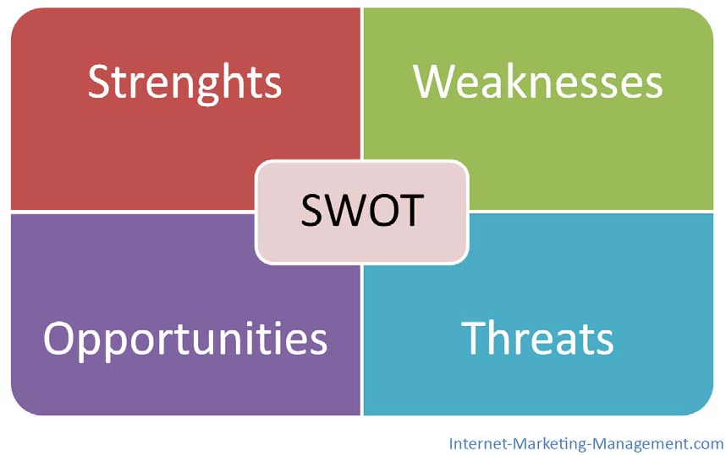

Figure - 25 SWOT
(Source – Internet-Marketing-Management.com) SWOT analysis of Amazon

Strengths

    - Amazon is among the world first online retailers and currently is the biggest among all globally. It derives its strength mainly from

      - Cost leadership
      - Distinct business model
      - Customer satisfaction

This strategy has helped the company to gain lot of loyal customers and shareholder earning profit from the company.

    - Amazon has maintained its competitive advantage by implementing IT (Information technology). It easy to ramp up platform ensures that it is always ahead of its competitors.

    - The goodwill earned by Amazon due to its satisfied customers in US has given it customers globally. It has helped it to enter new markets, which were a big challenge for other e-commerce companies.

    - Amazon superior logistics and distribution system has helped it to satisfy its customers and it has resulted in competitive advantage over its rivals.

Weaknesses

- In last couple of years, Amazon has diversified it product portfolio, which has shifted its focus from its core competence of retailing books online. It is good to diversity product portfolio but it is losing its strategic advantage, which has stabilized them in the market.

- Due to its free shipping policy on many products, it is in danger of losing its already thin margins. It will be difficult for them to optimize cost in future due to this strategy.

- Amazon is only an online retailer; the focus on retailing can become hindrance in its expansion plans especially in the emerging markets.

- One of the biggest weaknesses of Amazon is strategy of operating on waver thin margins. Company has huge volume and revenue but it has not translated into profitability for the company.

- Inventory management is still need to be improved to reduce delayed order and time.
- During peak season such as New Year or festive time, due to huge volume, Amazon delivery system has huge bottlenecks. It tarnishes company reputation and reduces customer satisfaction.

Opportunities

- Amazon has the opportunity to reduce the customers concern regarding security and privacy, which is among the top customer concern by launching its own payment system. Additionally, it will improve company margins by reducing cost involved in using third party payment gateway.

- Currently, Amazon is selling a tablet name Kindle in the market that is produced by it. It has become successful despite strong competition by its rival product. By launching more products under its brand it can open a new channel of revenue instead of being an online portal for third party products.

- Amazon can still increase its product portfolio. Its rival such as Flipkart has started selling automobiles such as car on their websites by collaborating with automobile companies. Increase portfolio will directly translate into higher revenues.

- Amazon is still only operates in 10 countries. It should expand globally and specially in the emerging market. It will certainly give them edge of being first mover in the competitive online retailing.

- Amazon in US is testing delivery via drones. If this delivery system becomes successful, it can be a game changer in the e-commerce industries.

Threats

- One of the major threats to Amazon’s success is the increasing customers concern over identity theft and hacking. It exposes customer’s private data. Amazon has to quickly address these concern by installing latest safety system to provide customer’s safe and secure online shopping.

- Amazon has aggressive pricing strategy by rolling out discount for the
product. It has led to company to face lawsuits from publisher and retail industry because it is selling products in losses to have increase customers numbers. It is under loss ever since it entered the Indian market. Implementing cost leadership strategy sometimes becomes a source of trouble for the company.

- It faces stiff competition from its local rival in India, who entered the market before them such as Flipkart. Applying its global strategy instead of local strategy based on local market condition can lose them market share.

- Due to loopholes in the delivery system, sometimes items are stolen while in transit. High reverse material flow also reduces company profit.

- Innovative ideas such as delivery via drones will be tough to implement because of the security concern raised by security establishment such as staking customer through it.

SWOT analysis of Flipkart Strengths
- Flipkart has earned customer’s loyalty toward it by offering 24*7 excellent customer services. The satisfied customer shop again using it which helped them to grow their business multi fold.

- Competitive pricing by offering huge discounts and better deals to customers especially on the highly popular products such as Mobiles phones.

- Flipkart website has a better search optimization for searching products and offer buying via websites within 6 clicks to make online shopping convenient to buyers.

- Promotion activities such advertisement are based according to the Indian market. It helps them to connect to buyers in a better way. It offer gift vouchers and gifts to its customers as promotion timely to boost sales.
- Flipkart has one of the widest range of payment options available to customers. It first started “Cash on Payment” method by studying Indian market where online payment options are still not very common. It now accounts more than 50% of the total sales of it. All the other companies are now offering the same option after watching its success in Indian market. It also have EMI option facility available to customers for certain product to have such customer on board who cannot pay at one go.

Weaknesses

- Even though Flipkart has its presence almost all over India but it still has less penetration at rural parts of the country.

- Early “Out of Stock” on some high selling product is very common especially during peak seasons such festivals times.

- Highly popular Cash on delivery payment option is not very economical for the company. Cases of customers rejecting to take delivery on this option is frequent. It cost them logistics charges. Cases of theft or snatching of items from deliveryman has also occurred in some part of the country.

- Promotional schemes such “The Big Billion day” failure due to logistics incapability of the company to deliver such high amount of products in a very short time.

- Despite being the market leader in term of total sales and revenue, it is still under losses. Its high discount policy resulted in high losses.

Opportunities

  - Flipkart should further increase its product portfolio by adding more items to its websites regularly. It started selling automobile recently that was positively received by customers. Items such as furniture should be added which are much in demand.

  - Indian market is still not fully covered and there is still a lot of area in the
country where online shopping is still a distant dream. Flipkart can cover those areas to boost its sales. It will also help in maintaining its market leader position.

  - Flipkart can start selling product under its brand like Amazon Kindle rather than acting only as platform for buyers and sellers. It will improve their profit margins but will also strengthen its brand image.

Threats

- Other e-commerce players such Amazon is catching up fast in term of sales and total market share.

- Failure of promotional schemes such as “The Big Billion day” can seriously affect company credibility in the long run.

- Government of India is in favour of allowing 100% FDI in multi brand retail in future. This can give edge to Amazon who has pioneered inventory model in US.

PORTER Analysis

The Porter’s Five Forces tool is a very powerful tool. It is simple but excellent for judging exactly where power lies. As it helps to understand not only the strength of current competitive position but also the strength of an expected position, it is very useful.

It is a critical part of your planning process. If you gain a proper understanding of where the power lies, you can take advantage of the company’s strengths. You can also improve your firm’s weaknesses. Overall, you will not take any wrong steps. It is shown in Figure 26.

(http://pestleanalysis.com/porters-five-forces-analysis/)

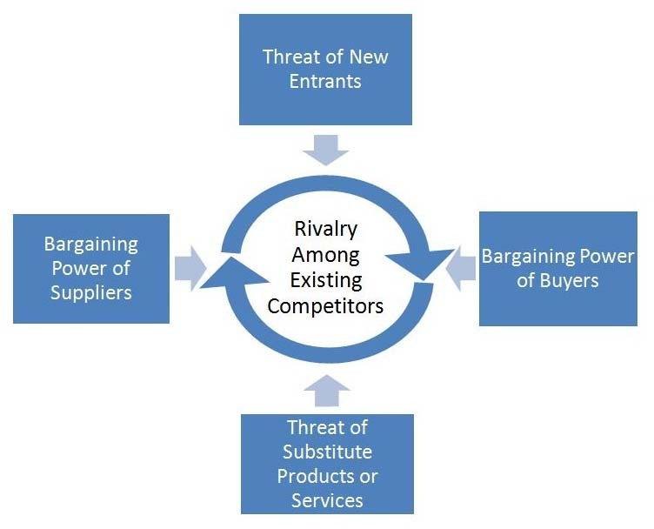

Figure – 26 PORTER

Supplier power:

E-commerce companies sell many products through its platforms ranging from books to electronics items to cosmetics etc. For each items, there are multiple suppliers who sell these products. In case of e-commerce, suppliers do not have much power. For example, if you take case of mobile phones category, there are many suppliers such as Apple, Samsung etc. who wants to sell their products through online portal. Online customers have the ultimate choice in choosing their product based on their requirement and cost. Manufacturer of these mobile phones cannot come to this industry due logistics challenges. They see this e-commerce company platform as medium to sell their products. E-commerce market in India is huge and manufacturers cannot afford to ignore this medium from which major part of their sales come. Due to it, manufacturers cannot put conditions on such e- commerce websites. This makes suppliers power very limited.

Buyer power:

Today, Industry is flooded with many players in each category of product such as mobile phones, electronic goods etc. The buyer has a lot of options to choose. Buyer can easily switch products because of very low switching costs. Variety of products is on display in several e-commerce companies and buyer can choose based on its requirement. It can also compare cost instantly, which is not possible in case of offline retail shopping. E-commerce companies roll out various schemes and discount frequently. It reduces product price and gives customer power to choose the best deal from any online retail-shopping portal. All these factors make buyer power more when compared to the E-commerce companies.

Threat of New Entrants:

Threat of new entrants is very high in this E-commerce industry due to the following reasons:

    - Indian government has recently allowed 100% FDI in marketplace model and sooner or later it will allow 100% FDI in multi-brand online retail inventory base model. So, this means new foreign companies can come and start their own online retail companies based on any model.
    - The investment required to start an E-commerce company is very less when compared to offline retail stores. To start, all is needed is to tie up with product suppliers and develop a website for displaying products with payment option where customers can buy.

    - E-commerce market in India is growing very fast. It is estimated that it will be
$80 billion market by 2020. It will attract more e-commerce from everywhere because of huge business opportunity.

Threat of substitutes:

Substitute to online industry are the physical offline stores currently. The threat is very low because customers are more and more moving toward online purchases because it saves them time, energy, and money. With increased penetration of Internet and smartphones around the globe especially in the developing countries, the future belongs to online retail. The quality is almost same in case customer buy it online or through physical stores. The operating costs are low in e-commerce compared to physical stores and heavy discount offered by online companies are unmatchable for physical stores. The substantial price difference in products prices helps in moving customers more toward online shopping. The competition is very high due presence of many e-commerce companies such as Flipkart, Amazon etc.

7.Types of Testing

Software testing strategy
The ultimate goal of functional testing is to ensure that software works according to specifications and in line with user expectations. While the objective sounds simple, the task involves many functional testing types, some of which might be preferred or prioritized over others depending on the nature of the application and organization.
Functional testing types
1.Unit testing: Before you can test an entire software program, make sure the individual parts work properly on their own. Unit testing validates the function of a unit, ensuring that the inputs (one to a few) result in the lone desired output. This testing type provides the foundation for more complex integrated software. When done right, unit testing drives higher quality application code and speeds up the development process. Developers often execute unit tests through test automation.
2.Smoke testing: Smoke testing, a type of acceptance testing, provides an initial check that a new software build and its critical functionality are stable. If the smoke tests pass, the build can undergo further testing. Smoke testing, also called build verification testing, often checks whether new or critical functionality meets its objective. If the tests don’t pass, as the saying goes, “where there’s smoke, there’s fire,” and additional dev work is required.
3.Sanity testing: A type of regression testing, QA professionals perform sanity testing on new versions of stable builds to validate either new functionality or bug fixes. While similar to smoke testing in that both provide a gate check that a build is ready for more testing, sanity testing is unscripted and specifically targets the area that has undergone a code change.
4.Regression testing: Just because functional tests pass once doesn’t mean they’ll always pass. When developers commit new code or change a feature, you run regression tests to make sure the software still functions as expected. Regression testing helps maintain a stable product while changes are made to it. Regression tests are often automated
5.UI testing:With UI testing, QA professionals interact with the graphical interface of a software program. This includes testing of UI controls like buttons, menus and text input to ensure that the experience flow and features chosen are optimal for the user experience.
6.System testing: With system testing, QA professionals test the software in its entirety, as a complete product. With this type of functional testing, testers validate the complete and integrated software package to make sure it meets requirements. Where necessary, testers can provide feedback on the functionality and performance of the app or website without prior knowledge of how it was programmed. This helps teams develop test cases to be used moving forward. System testing is also referred to as end-to-end testing.
7.Black-box testing: Contrary to white-box testing, black-box testing involves testing against a system where the internal code, paths and infrastructure are not visible. Thus, testers use this method to validate expected outputs against specific inputs. Any time where a QA professional doesn’t look into the code before testing can be considered black box. With black-box testing, the organization can test the software in the same way a customer would experience it. Black-box testing encompasses a variety of non-functional and functional testing types, depending on the objective of the test.
8.Alpha testing:Another subset of acceptance testing, alpha testing uses internal team members to evaluate the product. These team members should be knowledgeable of the project but not directly involved in its development or testing. Where some builds might still be somewhat unstable, alpha testing provides an immediate subset of testers to root out major bugs before the software is seen by external users.
9.Beta testing: After the internal team tests the product and fixes bugs, beta testing occurs with a select group of end users. Beta testing serves as a soft launch, enabling you to get feedback from real users who have no prior knowledge of the app. Beta testing enables you to gather feedback from unbiased users who may interact with the product differently than you intended, perhaps identifying critical unknown bugs before release to a wide user base.

.

8.UML Diagram
UML Diagram:
A UML diagram is a diagram based on the UML (Unified Modeling Language) with the purpose of visually representing a system along with its main actors, roles, actions, artifacts or classes, in order to better understand, alter, maintain, or document information about the system.

- Class Diagram:Class diagrams are the most common diagrams used in UML. Class diagram consists of classes, interfaces, associations, and collaboration. Class diagrams basically represent the object-oriented view of a system, which is static in nature.
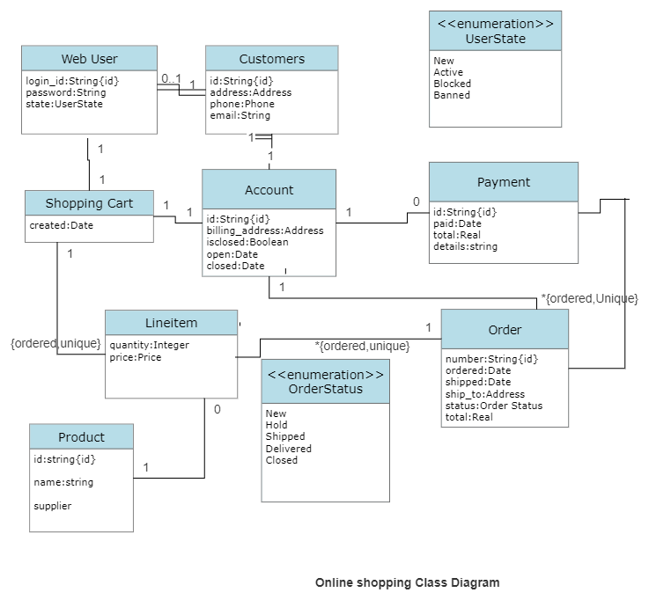
2.Deployment Diagram:Deployment diagrams are a set of nodes and their relationships. These nodes are physical entities where the components are deployed.

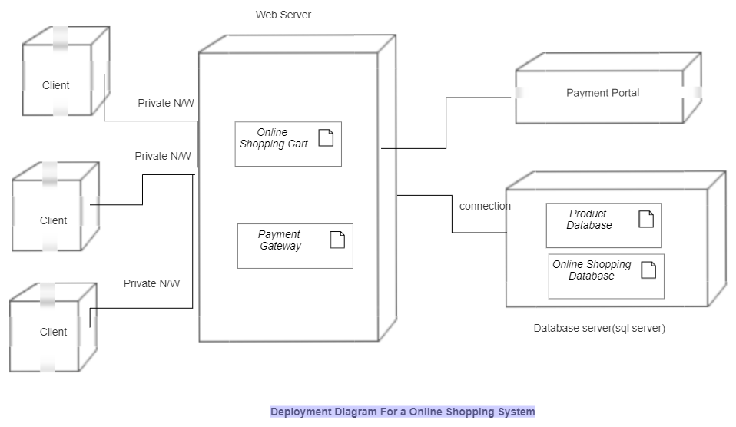
3.Object Diagram:Object diagrams can be described as an instance of class diagram. Thus, these diagrams are more close to real-life scenarios where we implement a system.

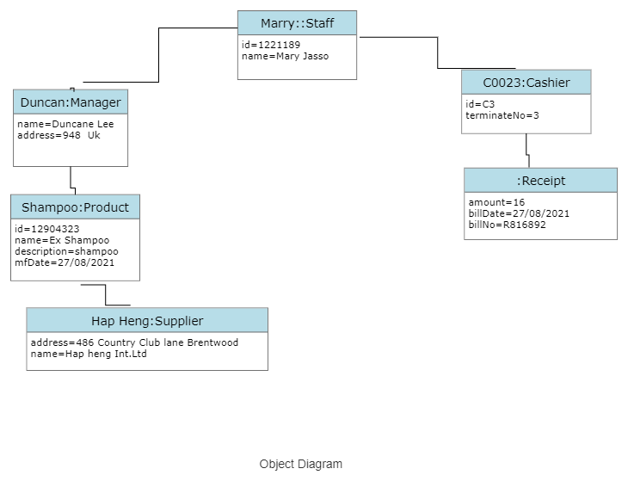

Package diagram : Package diagram is UML Structure diagram which shows structure of the designed system at the level of packages. The following elements are typically drawn in a package diagram: package, packageable element, dependency, element import, package import, package merge.
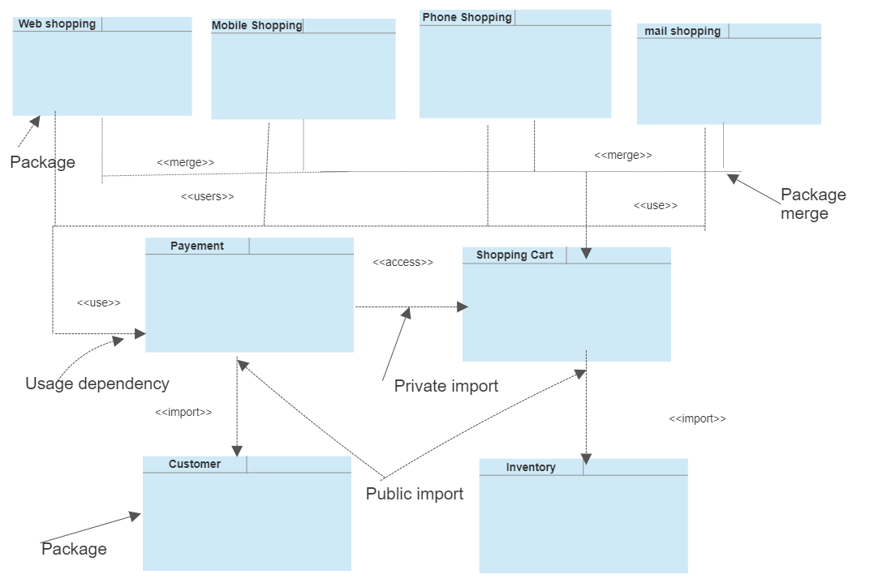

Package Diagram
    - Use case diagram:Use Case Diagram captures the system’s functionality and requirements by using actors and use cases. Use Cases model the services, tasks, function that a system needs to perform. Use cases represent high-level functionalities and how a user will handle the system. Use-cases are the core concepts of Unified Modelling language modeling.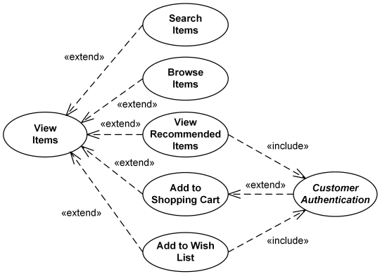

9. Conclusion

India e-commerce market is growing at a rapid pace. With economy growing around 7.5% each year, it is one of the fastest growing economies in the world currently. The online shopping is here to stay and will be used extensively in coming years. The two biggest companies Flipkart and Amazon are finding out ways to retain profit in long term with improved logistics and customer satisfaction.

Amazon has entered the Indian market at a nearly perfect time. The growth of Indian economy is growing at a fast pace and which has improved people living standard overall. India provides Amazon with limitless opportunities in the coming years. Amazon has to roll out its future strategies considering big threats that will affect them in coming years. Firstly, strategy of heavy discounting on products to grab more market share and customer need to be relooked by the company. Volume and market leadership are not the only factors, which add value to its stock. Secondly, it need to sort out delivery shortcomings and website crashing during festive season. It will not only increase customer satisfaction but will also help in adding more new customers. Thirdly, it needs to keep innovating to be ahead in the market. The concept of same delivery with additional cost enjoyed success in Indian market and it needs to keep innovating like it to grab more market share. Indian market is very competitive and competitor like Flipkart regularly comes with newer ideas. Finally, it should broad its reach in Indian market. It is currently present only in 50 big cities and a lot of rural market is still untapped. It should start adding new areas under its delivery range.

A competitive rival can give boost to company performance incredibly and Amazon is exactly such a rival. It has pushed Flipkart to launch innovative payment methods such a PayZippy for online sellers and buyers who seek hassle free and safe payment options. It launched its own logistics branch to improve delivery and customer service experience. Currently, it handles more than 50% of the total shipments. It also introduces next day delivery option that was started by Amazon. Just as Amazon, Flipkart will also have to address some of the basic threats that loom over the industry such as heavy discounting policy, innovation in payment gateways, logistics, expansion etc.
10.List of figures

Evolution of logistics
  - B2C E-commerce sales growth worldwide

E-commerce market growth in India
  - Government restriction in FDI in India

Evolution Logistics
  - Difference between conventional and e-commerce retail logistics

Storage Racks
  - Automated Picking Robots

Conveyor Belts
  - Digital Weighing Machine

Sales forecast in India
  - Indian E-commerce market share in 2015

Market place model
  - Inventory based model

Inventory Management System
  - Returrn Process

Flipkart Funding
  - Flipkart Warehouse Management Systems

Order fulfillment process
  - Product Offering Comparison between Flipkart and Amazon

Product portfolio of Amazon and Flipkart
  - Social medial popularity

Mobile download and daily usage
  - Net revenue and losses

SWOT
  - PORTER

List of Tables

Difference between Qualitative and Quantative research
- Flipkart company structure

